

SCHOOL OF COMPUTING AND INFORMATICS
BACHELOR OF SCIENCE IN INFORMATION TECHNOLOGY
UNITE TITLE: ADVANCED CRYPTOGRAPHY
UNITE CODE:
PROJECT TITLE: SECURITY AND ENUMERATION

SUBMITTED BY: MAINA JOSHUA
REG. NO: BSCCS/2024/47667

SUPERVISOR: MR. MICHAEL NYORO

ADVANCED CRYPTOGRAPHY
SELECTED TECHNOLOGIES
ONLINE PORTFOLIO
Table of Contents
No table of contents entries found.
A PSEudorandom Sequence generator in Python
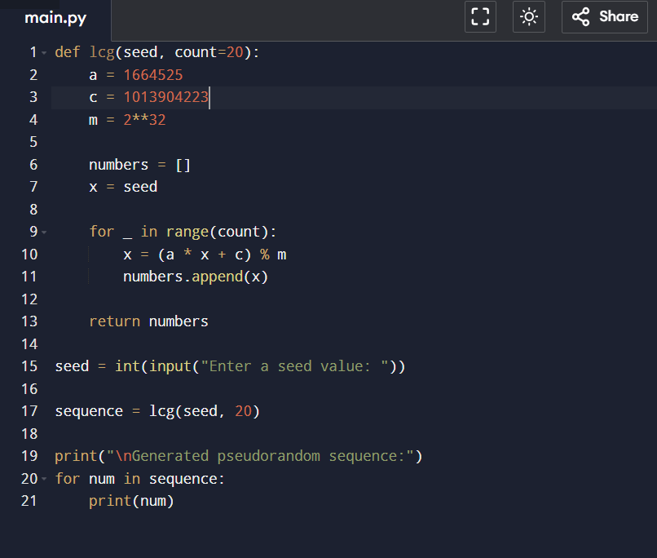Pseudo random generator
Utilisationof the same seed value outputs Similar values
Period
The generator can have a maximum period of 2³² (4,294,967,296) values before the sequence repeats, which is much longer than the 20 values generated.
Randomness Observations
The numbers appear random with no obvious short-term pattern.
The same seed always produces the same sequence.
Different seeds produce different sequences.
It is suitable for basic simulations but not for cryptographic use because it is predictable.
Mini Research Report
1. One-Time Pad (OTP)

The One-Time Pad (OTP) is an encryption technique that uses a random key that is the same length as the message. Each character of the plaintext is combined with the corresponding character of the key to produce ciphertext.
Advantages
- Provides perfect secrecy when used correctly.
- Impossible to crack through brute force.
Disadvantages
- Requires a truly random key.
- Key must be as long as the message.
- Secure key distribution is difficult.
Real-World Applications
Military and diplomatic communications.
Highly sensitive data transmission where maximum security is required.
due to security weaknesses and replaced by stronger encryption algorithms.
RC4 Stream Cipher
RC4 is a stream cipher developed by Ron Rivest in 1987. It generates a pseudorandom keystream that is combined with plaintext using the XOR operation to create ciphertext.
Advantages
- Fast and simple to implement.
- Requires low computational resources.
Disadvantages
- Vulnerable to several cryptographic attacks.
- No longer considered secure for modern applications.
Real-World Applications
Previously used in SSL/TLS and WEP.
Largely deprecated due to security weaknesses and replaced by stronger encryption algorithms.
MODIFIED XOR PROGRAM
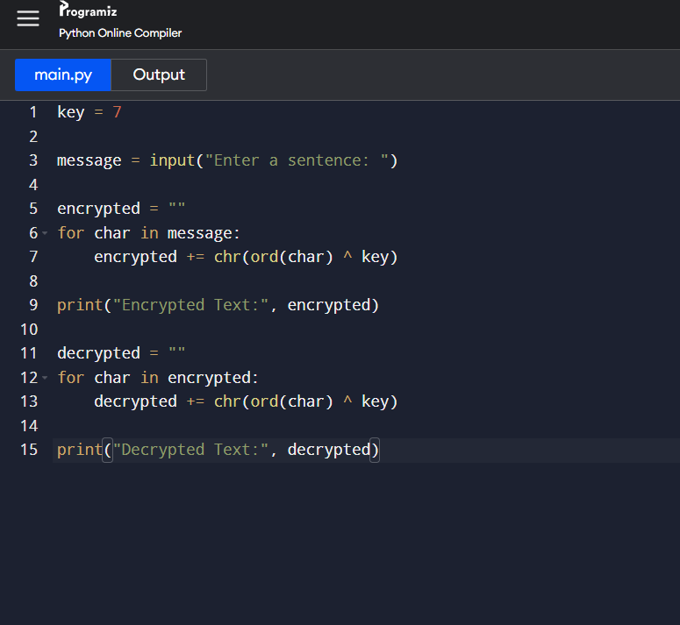
MENU DRIVEN STREAM CIPHER APPLICATION
